ADVANCED DATA ANALYSIS USING
FORMULAS AND PIVOTTABLES
Netflix Movies and TV Shows Dataset
Internship Assignment Report | Fresher Level
Student Name: ______________________________
Course / Internship: __________________________
Date: ______________________________________

1. Introduction
This report explains an Excel-based analysis of a Netflix Movies and TV Shows dataset. The purpose of this assignment is to understand how a fresher data analyst can use Excel formulas, PivotTables, charts and data summarization techniques to convert a large table into useful information. Instead of checking thousands of rows one by one, I grouped the information, calculated important measures and studied patterns in the catalogue.
The analysis uses the Excel workbook supplied for this assignment. It contains 8,790 records and 10 original data fields in the Raw_Data sheet. The fields include show ID, content type, title, director, country, date added, release year, rating, duration and genre/category. The workbook also contains Cleaned_Data, Quality_Check and Summary sheets. I used the cleaned sheet for most calculations and checked the original sheet to understand the starting data.

2. Objectives
- Understand the structure and meaning of the Netflix dataset.
- Use Excel formulas to count, classify, compare and summarize records.
- Explain nested formulas, conditional formulas and dynamic array functions.
- Create PivotTable summaries for content type, date added, country and genre.
- Use charts to make findings easier to understand.
- Write simple business observations and recommendations based on the results.

3. Dataset Description and Preparation
The dataset contains 8,790 title records. Each row represents one movie or one TV show. The Type field separates the two content formats. Date Added tells when a title was added to the Netflix catalogue, while Release Year tells when the movie or show was originally released. These two fields answer different questions and should not be mixed up.
The workbook's Summary sheet reports 8,790 rows, 10 original columns, zero full duplicate rows, zero blank cells and 8,790 unique show IDs. The Quality_Check sheet also reports no missing values in the ten original fields. This means the supplied file is already in a relatively prepared condition. I have not claimed that missing values were removed because the workbook does not show missing values.
The Cleaned_Data sheet includes two useful extra fields: duration_value and duration_unit. These split the original Duration text into a number and a unit. For example, a movie duration such as '90 min' becomes 90 and 'min'; a TV show duration such as '2 Seasons' becomes 2 and 'Season'. This makes numerical calculations easier. The sheet also includes cleaning-check information. One additional unnamed column is mostly blank, so it should be reviewed or removed before presenting a final clean table.
A data-quality caution is that the country field may contain more than one country in a single cell, and the listed_in field can contain several genres separated by commas. A normal PivotTable treats the complete cell text as one category. For a more accurate country or genre ranking, the text should be split into separate rows using Power Query or Text to Columns. When doing this, avoid adding the expanded row count to the original title count because one title can appear in more than one category.

4. Methodology
I followed a simple analysis process. First, I checked the sheets and columns. Second, I reviewed the quality summary and confirmed the record count. Third, I used the cleaned data to calculate content totals, duration measures and date-added trends. Fourth, I designed PivotTable layouts to compare categories. Finally, I prepared charts and interpreted the results in business language.
Before starting in Excel, I would convert the Cleaned_Data range into an Excel Table by selecting a cell in the data, pressing Ctrl+T and confirming that the table has headers. From Table Design, I would name it tblNetflix. A table expands automatically when new records are added and makes formulas easier to read.

5. Advanced Excel Formulas Used

5.1 Counting and conditional formulas
COUNTA counts non-empty cells. For example, =COUNTA(Cleaned_Data!C2:C8791) counts the title records. COUNTIF counts records that meet one condition. =COUNTIF(Cleaned_Data!B2:B8791,"Movie") returns 6,126, while =COUNTIF(Cleaned_Data!B2:B8791,"TV Show") returns 2,664. COUNTIFS can apply more than one condition. For example, =COUNTIFS(Cleaned_Data!F2:F8791,">="&DATE(2019,1,1),Cleaned_Data!F2:F8791,"<"&DATE(2020,1,1)) counts titles added during 2019.

5.2 AVERAGEIFS and summary calculations
AVERAGEIFS calculates an average only for rows that match a condition. The formula =AVERAGEIFS(Cleaned_Data!K2:K8791,Cleaned_Data!B2:B8791,"Movie") calculates the average movie duration from duration_value. The result is about 99.6 minutes. For TV shows, the average duration_value is about 1.75 seasons. These averages must be explained separately because one is measured in minutes and the other in seasons.

5.3 IF and nested IF
IF checks a condition and returns one result when it is true and another when it is false. For example, =IF(B2="Movie","Movie","TV Show") labels a row based on its type. A nested IF places one IF formula inside another. An example is =IF(B2="Movie",IF(K2>=120,"Long movie","Standard/short movie"),IF(K2>=3,"Long-running show","Short/standard show")). This classifies movies at 120 minutes or more as long movies and TV shows with three or more seasons as longer-running shows. These thresholds are selected for practice and are not official Netflix definitions.

5.4 IFERROR and lookup functions
IFERROR prevents a formula from showing an error when a lookup does not find a match. For example, =IFERROR(XLOOKUP(A2,Cleaned_Data!A:A,Cleaned_Data!C:C),"ID not found") searches for the show ID and returns its title. If the ID is not found, it displays "ID not found". XLOOKUP is available in newer Excel versions; older versions can use VLOOKUP or INDEX and MATCH.

5.5 Dynamic array functions
Dynamic array functions return multiple results and automatically spill into nearby cells. In Microsoft 365 or a supported newer Excel version, =SORT(UNIQUE(Cleaned_Data!B2:B8791)) creates a sorted list of unique content types. =FILTER(Cleaned_Data!A2:N8791,Cleaned_Data!B2:B8791="Movie","No matches") returns all movie rows. These functions reduce the need to copy formulas down many rows.

5.6 LET and TEXTSPLIT
LET gives names to calculations inside a formula, making a long formula easier to read. For example, =LET(titles,COUNTA(Cleaned_Data!C2:C8791),movies,COUNTIF(Cleaned_Data!B2:B8791,"Movie"),movies/titles) calculates the share of movies. TEXTSPLIT can separate comma-separated genres. For example, =TEXTSPLIT(I2,", ") splits the categories in a listed_in cell. Availability of TEXTSPLIT, FILTER, UNIQUE, SORT, LET and XLOOKUP depends on the Excel version.

6. PivotTable Creation: Step-by-Step
A PivotTable summarizes a large dataset without writing a separate formula for every category. The following steps describe how to build the main summaries in Excel.
- Open Cleaned_Data and click any cell inside the dataset.
- Press Ctrl+T to format the range as a table, if it is not already a table. Confirm that My table has headers is selected.
- Choose Insert > PivotTable. Select the table or range and choose New Worksheet.
- To compare Movies and TV Shows, drag Type to Rows and Show ID to Values. Set Values to Count if Excel does not select Count automatically.
- To study titles added over time, drag Date Added to Rows and Show ID to Values. Right-click a date, choose Group and select Years. If grouping is unavailable, add a Date Added Year helper column using =YEAR(F2) and use that field in Rows.
- To compare countries, drag Country to Rows and Show ID to Values. Apply a value filter to show the top 10 countries. Remember that multiple countries in one cell are treated as one combined label.
- To compare genres, drag Listed In to Rows and Show ID to Values. This counts complete genre combinations, not individual genres. For individual genre counts, first split Listed In into separate rows with Power Query.
- Click inside a PivotTable and choose PivotTable Analyze > PivotChart. Select a column chart for content type or a line chart for yearly additions.
- Give each PivotTable a clear name and add a short note explaining what its values represent.
The companion workbook includes a Pivot_Summary sheet with calculated summary tables to make the results easy to review. These are summary outputs, not native interactive PivotTable objects. To complete the practical PivotTable activity, follow the steps above in Excel and save the created PivotTables in your workbook.

7. Analysis Results and Visual Findings

7.1 Movies compared with TV shows
The dataset contains 6,126 movies and 2,664 TV shows. Movies represent approximately 69.7% of the catalogue, while TV shows represent approximately 30.3%. This shows that movies form the larger part of the dataset. A PivotTable with Type in Rows and Count of Show ID in Values makes this comparison clear.
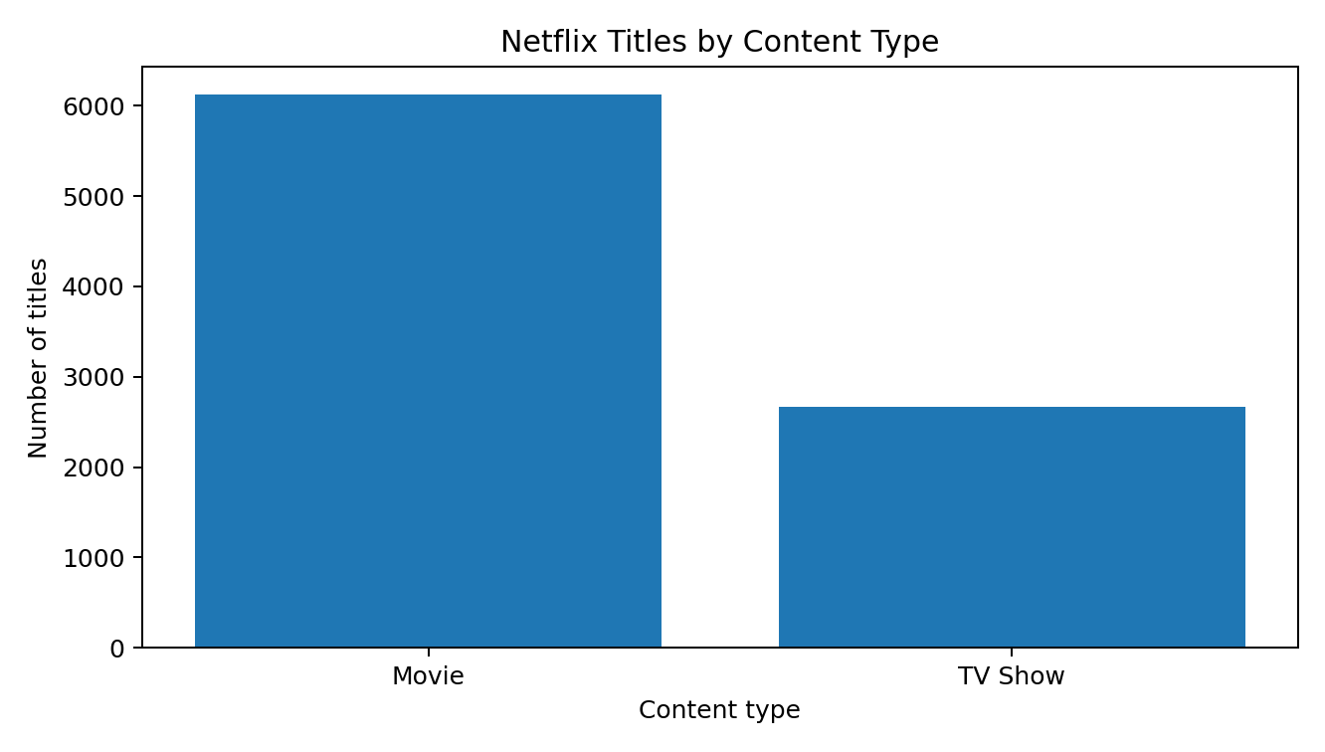

7.2 Titles added by year
The largest number of titles in this dataset was added in 2019, with 2,016 titles. The next highest years were 2020 with 1,879 titles, 2018 with 1,648 titles and 2021 with 1,498 titles. The count falls sharply before 2016. This suggests that the dataset contains many titles added during Netflix's catalogue expansion period. It does not prove that Netflix produced all these titles; Date Added only records when a title appeared in the catalogue.
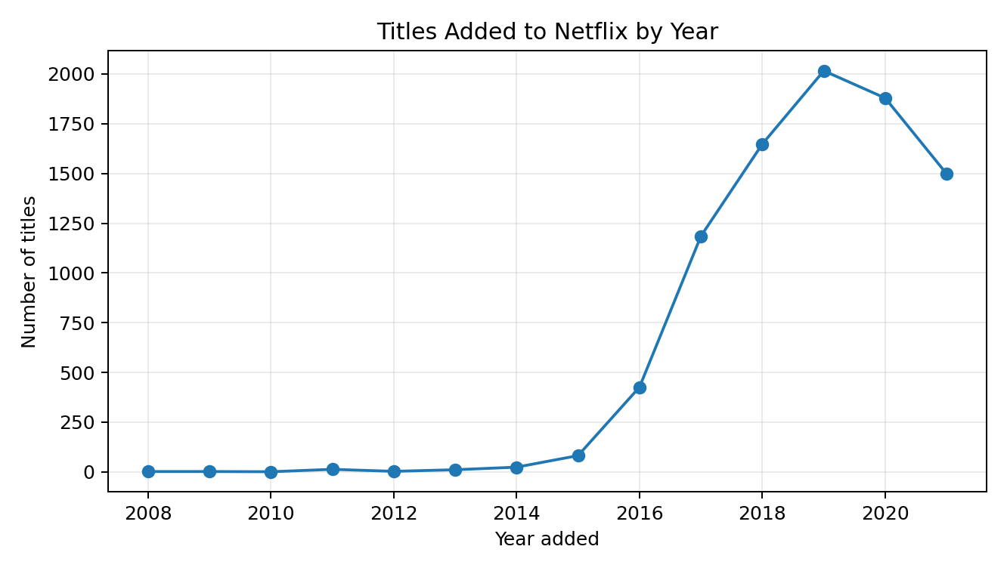

7.3 Countries
The highest country count is United States with 3,240 records, followed by India with 1,057 and United Kingdom with 638. Pakistan has 421 records, while Canada has 271. These figures describe the country field as stored. Some titles may list more than one country in the same cell, so the counts are not a perfect count of unique productions by country. The result still provides a useful first view of the catalogue's geographic representation.
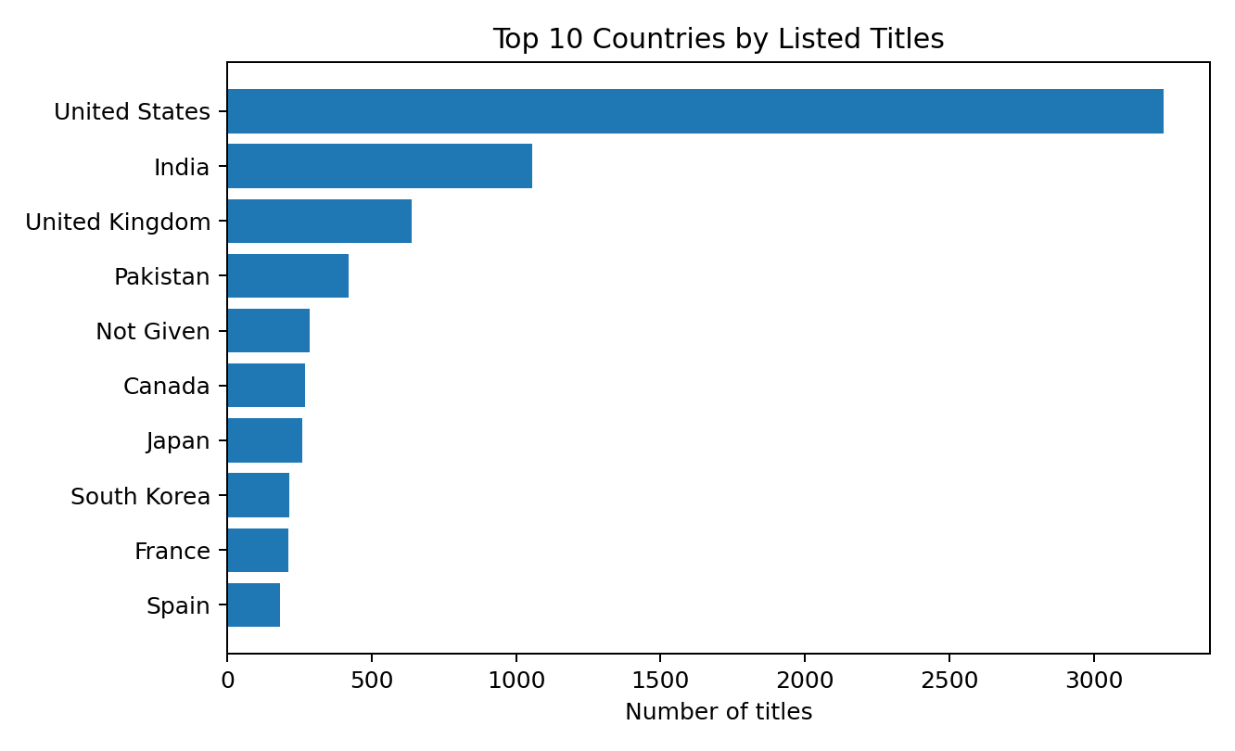

7.4 Genres and categories
When the Listed In field is split on commas and spaces, International Movies appears most often with 2,752 title-genre entries, followed by Dramas with 2,426 and Comedies with 1,674. International TV Shows has 1,349 entries. These counts can overlap because one title can belong to multiple genres. Therefore, genre counts should not be added together to estimate the number of unique titles.
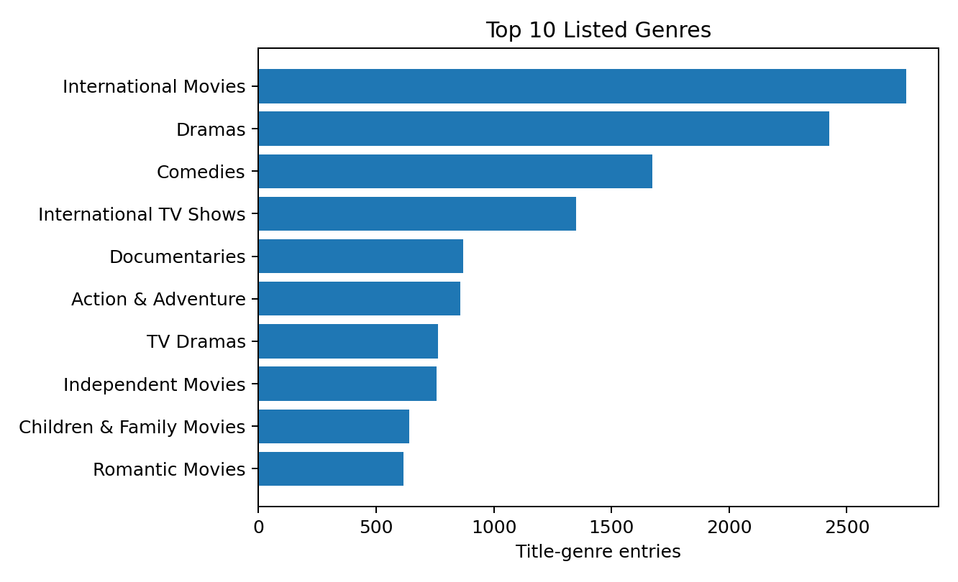

7.5 Duration analysis
The average movie duration is about 99.6 minutes and the median is 98 minutes. The middle half of movie durations falls approximately between 87 and 114 minutes. The longest movie in the dataset is 312 minutes and the shortest is 3 minutes, so checking unusual values is sensible before making business conclusions. TV shows average about 1.75 seasons, and the median is one season. Averages for movies and TV shows should not be compared directly because their units are different.

8. Key Business Insights
- Movies make up close to seven out of every ten records, so the catalogue is movie-heavy.
- The strongest Date Added years are 2018 to 2021, with 2019 as the peak year in this extract.
- The United States and India are the two largest country labels in the data.
- Drama, International Movies and Comedy are prominent categories. These may be useful when planning content discovery and recommendation pages.
- The typical movie in the dataset is around 98 to 100 minutes, while most TV shows have one season.

9. Recommendations
- Review the balance between movies and TV shows when planning catalogue acquisition.
- Use country and genre breakdowns to check whether the catalogue is balanced across markets and viewer interests.
- Refresh PivotTables regularly so new records can be compared with earlier periods.
- Use Power Query to split multiple countries and genres into separate rows before detailed category analysis.
- Review unusual duration values, such as very short or very long movies, to confirm that source data is correct.
- Use slicers for Type, Country and Release Year so a manager can interact with the PivotTable report.

10. Challenges and Learning Outcomes
As a fresher, the main challenge was understanding that Release Year and Date Added are different. Release Year tells when the content was originally released, while Date Added tells when it was added to Netflix. Another challenge was the mixed duration units: movies use minutes and TV shows use seasons. I used duration_value together with duration_unit and calculated averages separately. A further challenge was that some country and genre cells contain multiple values. I noted this limitation and recommended Power Query to split them for more detailed analysis. I also learned that a PivotTable summary and a dynamic formula result are different tools: PivotTables are interactive summaries, while formulas calculate results directly in cells.

11. Conclusion
This assignment helped me understand how Excel can be used for more than entering data and making simple tables. By using COUNTA, COUNTIF, COUNTIFS, AVERAGEIFS, IF, nested IF, IFERROR, XLOOKUP, UNIQUE, SORT, FILTER, LET and TEXTSPLIT, I can calculate useful measures and prepare data for analysis. PivotTables make it easier to summarize thousands of records, while charts help explain the results to other people. The analysis found that movies form about 69.7% of the records, 2019 is the highest year for Date Added, and the United States and India are the most common country labels. As a beginner, I learned the importance of checking data quality, choosing the correct fields, understanding limitations and explaining results in simple business language.

12. Appendix: Formula Reference
Function | Example | Use
COUNTIF | =COUNTIF(B:B,"Movie") | Count rows matching one condition
COUNTIFS | =COUNTIFS(F:F,">="&DATE(2019,1,1),F:F,"<"&DATE(2020,1,1)) | Count rows matching multiple conditions
AVERAGEIFS | =AVERAGEIFS(K:K,B:B,"Movie") | Average values for a selected group
IF | =IF(B2="Movie","Movie","TV Show") | Return a result based on a condition
IFERROR | =IFERROR(XLOOKUP(A2,A:A,C:C),"Not found") | Show a friendly result if a formula errors
UNIQUE / SORT | =SORT(UNIQUE(B2:B8791)) | Create sorted distinct values
FILTER | =FILTER(A2:N8791,B2:B8791="Movie") | Return rows matching a condition
LET | =LET(a,COUNTA(C:C),b,COUNTIF(B:B,"Movie"),b/a) | Name intermediate calculations
TEXTSPLIT | =TEXTSPLIT(I2,", ") | Split comma-separated categories
Note: Formula examples use the supplied Cleaned_Data column positions: B = Type, C = Title, F = Date Added, I = Listed In and K = duration_value. If columns are moved, update the cell references. In an Excel Table, structured references such as tblNetflix[Type] can make formulas easier to maintain.

